**CD_Inventory**

**Object Oriented Programming**

***Introduction:***

In this module we got introduced with a whole new and very interesting subject: Object oriented programming. We started to work with Classes and Objects and got antiquated with Constructors, Fields, Attributes and Methods. It was quite a difficult and challenging task to work with this new subject.

*(Img. 01)*

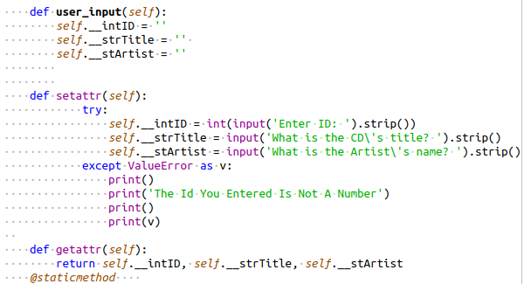

I started working with IO class. Here I created “user”_input function and defined functions for getting and setting attributes in it “setattr” and “getattr”, in “setattr” but encountered some issues with using method properties so, I’m still trying to work on this problem. *(Ref.FDN.Mod08.p07)*

The next method in this class I worked on was “menu_choice()”. With it I defined a “checkValue ()” function for validating values in user input. *(REFF.* [*https://www.geeksforgeeks.org/getter-and-setter-in-python/*](https://www.geeksforgeeks.org/getter-and-setter-in-python/)*) (img02)*

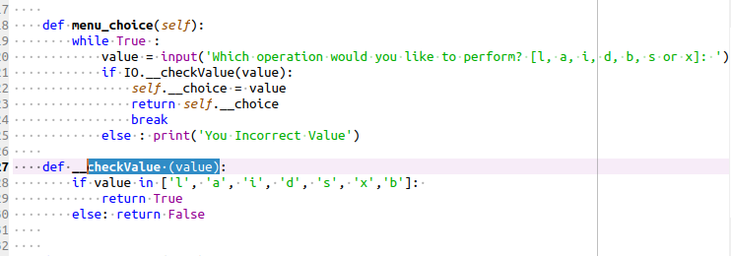

There are 3 more functions in “IO:” class: “show inventory”, “pickle choice”, and “print menu” this functions use @static method and were described in detail in the previous lesson.

In the next class “FileIO:” I tried to use @classmethods decorator I still work on my knowledge base to fully define differences in the decorators using on methods in Python object oriented programming. I made this decision because all 4 methods used here named: “read_file”, “write_file”, “pickle_processor_dump”, “pickle_processor_load” are exclusively used within “FileIO” class and called by class objects only. *(REFF. https://www.geeksforgeeks.org/class-method-vs-static-method-python/#:~:text=A class method is a,the instances of the class.) (img.03)*

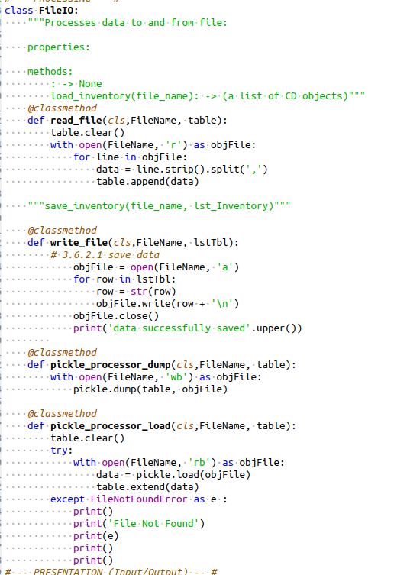

In the very last class introduced in my program: “CD:” I used “__init__” constructor to apply cd attributes to newly created objects by default. I also used “__str__” method to modify default output for print() function and one more additional method to append entries to the table and return data to the mai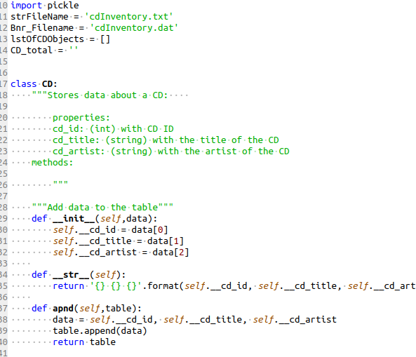n function. (*FDN.MOD08. 03) (img04)*

*Conclusion:*

I tried to describe my understanding of the Object oriented Programming from my point of view. I know that there is very long way to go but I really put a lot of effort into this and I really enjoyed such interesting challenging assignment.

*P.S.*

*I want to thank you for all the time and energy you spend on these lectures.*

